Exadata Storage Cells Performance – Flash vs Hard Disk

By Karl Arao

# The data set

The data set used is coming from the storage cell metrics with the following variables (columns).

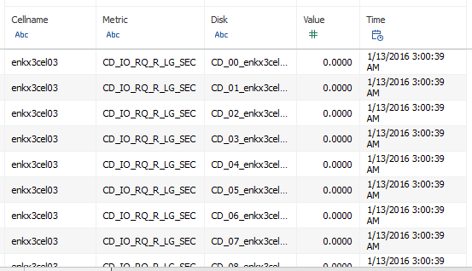

# Example reports

The objective is to generate performance reports for an Exadata Cluster. The analysis can be done by IOPS, Bandwidth, and Latency across dimensions (Flash/HD, IO type, Storage Cell, Grid Disk, etc.). Also this new version has additional metrics about flash cache, flash log, and storage cell health metrics (CPU, memory, filesystem space, etc.). Below are some example graphs:

## Flash vs HD

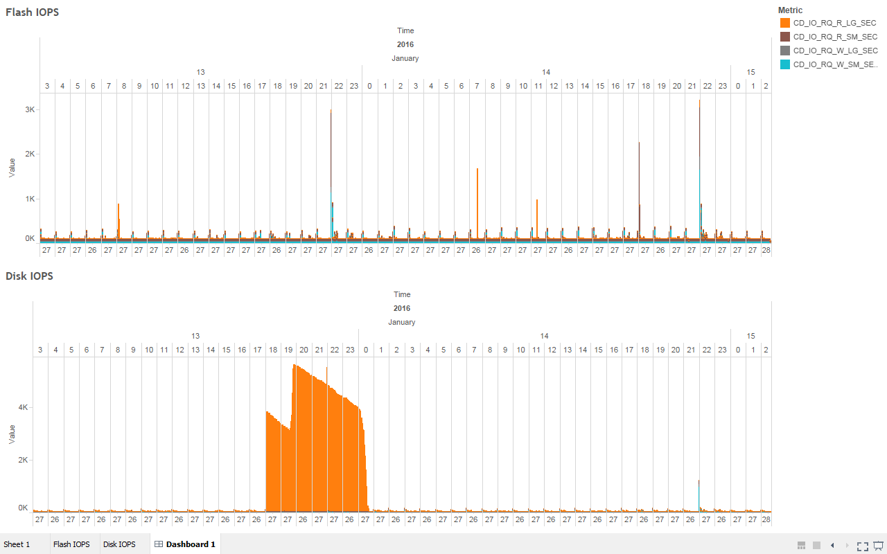

## Flash vs HD IO type breakdown

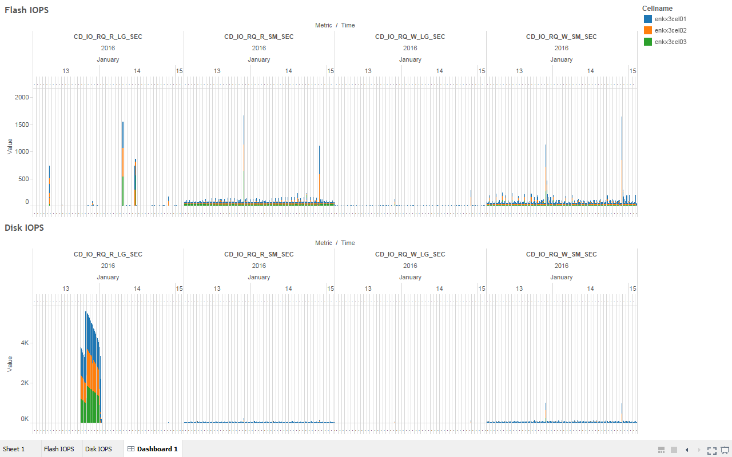

## Flash vs HD by Storage Cell

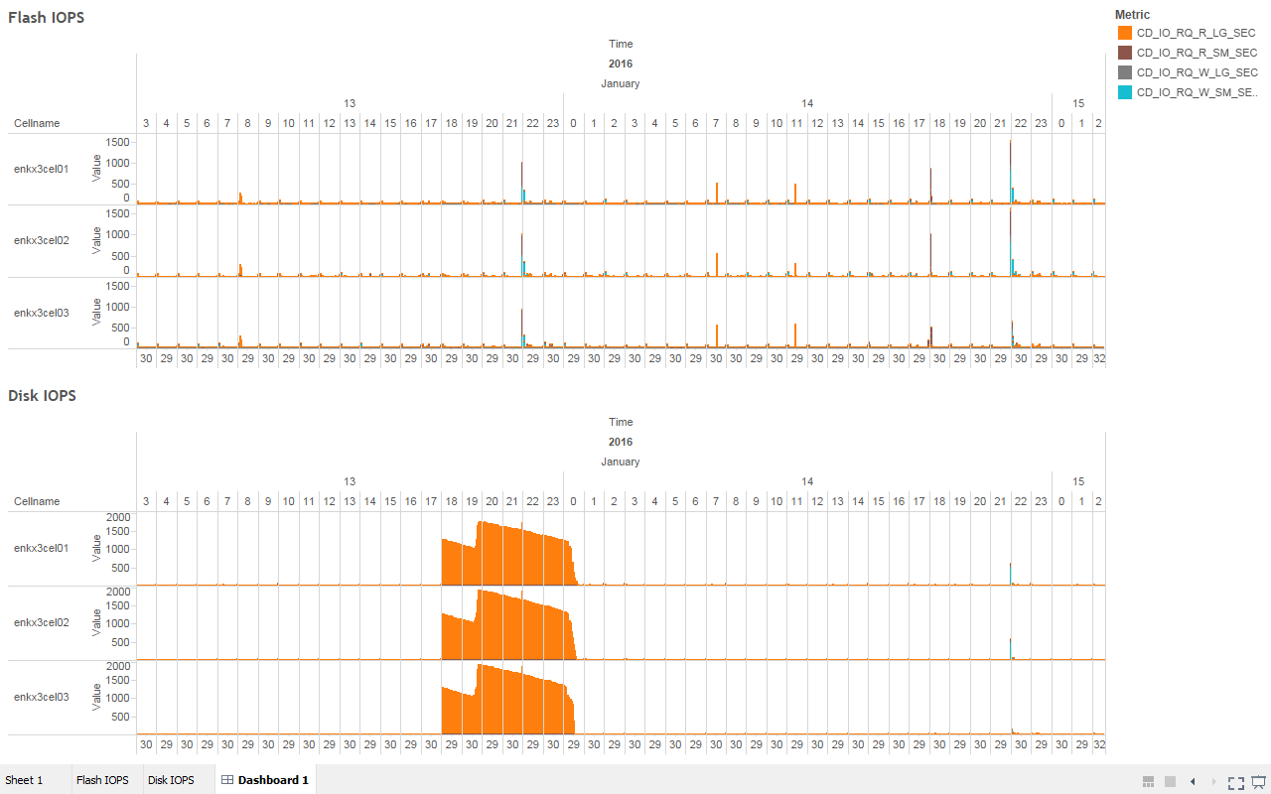

## Flash vs HD by Grid Disk

Here the CD_03 HD is shown to be pushing 142 IOPS which is on the range of the limit of the device, meaning at that time it is 100% busy

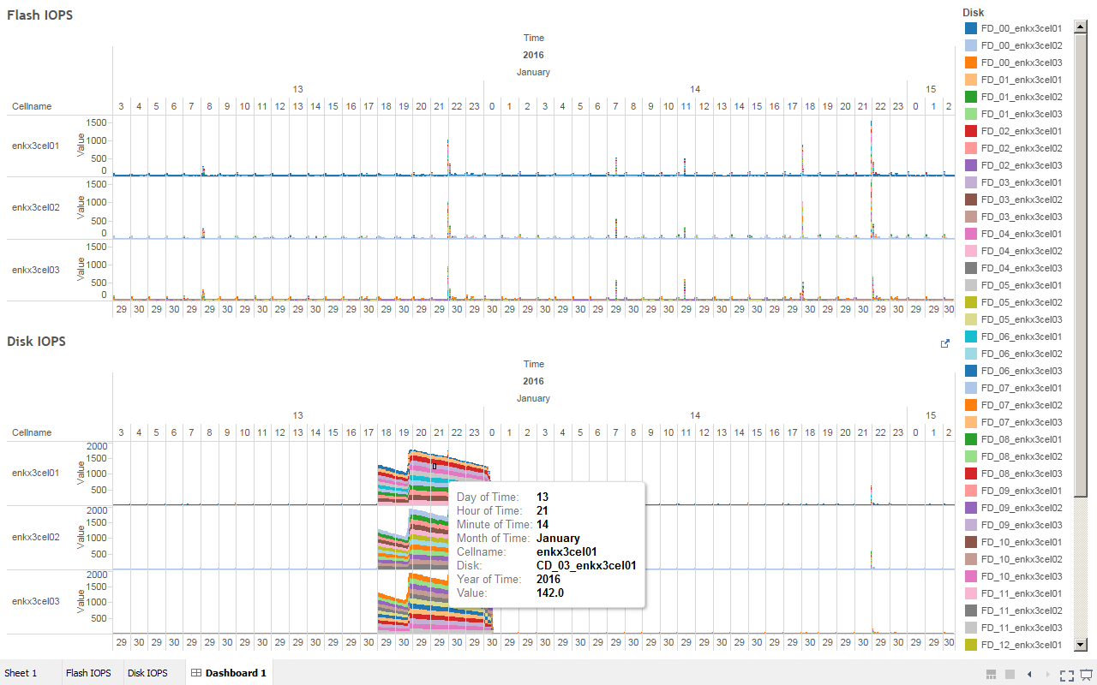

## New graphs

### Storage cell health metrics

The main metrics are MB/s reverse offload and passthru, CPU%, memory%, filesystem space%, IORM mode

The cell metric (MB/s) SIO_IO_RV_OF_SEC is "reverse offload" (when there is high CPU on the cells) and SIO_IO_PA_TH_SEC is passthru (row chaining & migration among them)

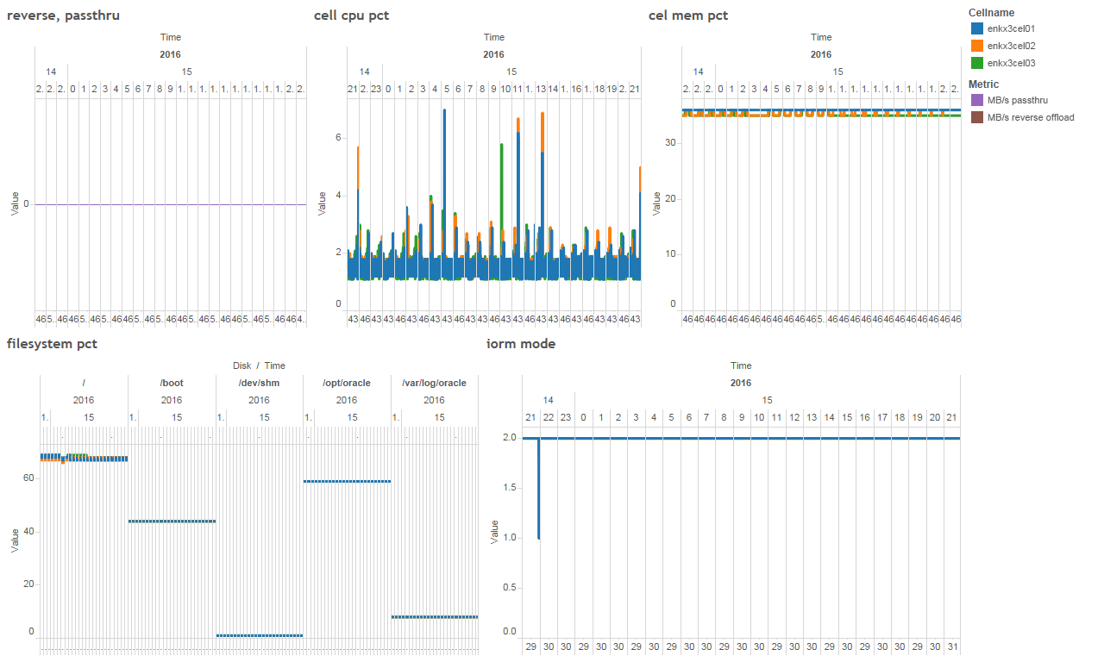

### Flash cache destage

Measures how much destage is happening

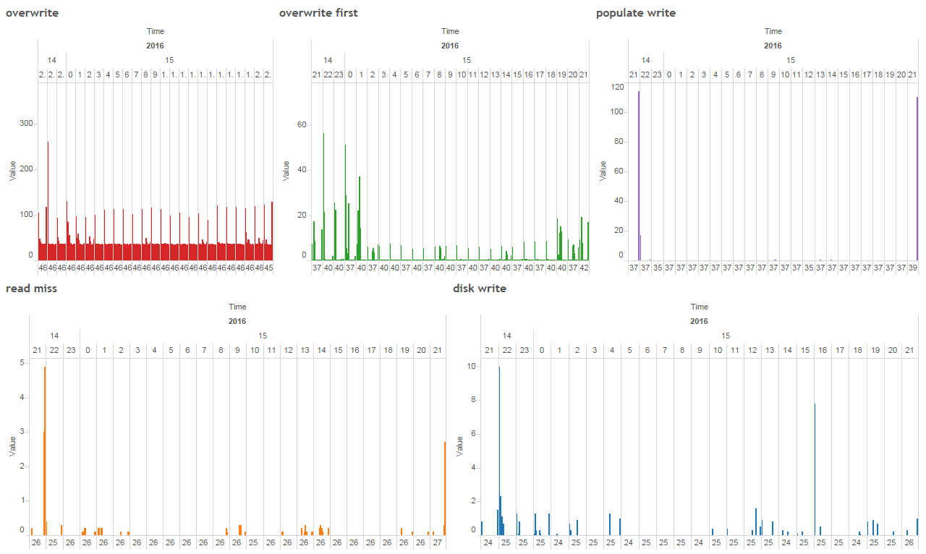

### Flash cache space

The space usage in flash cache

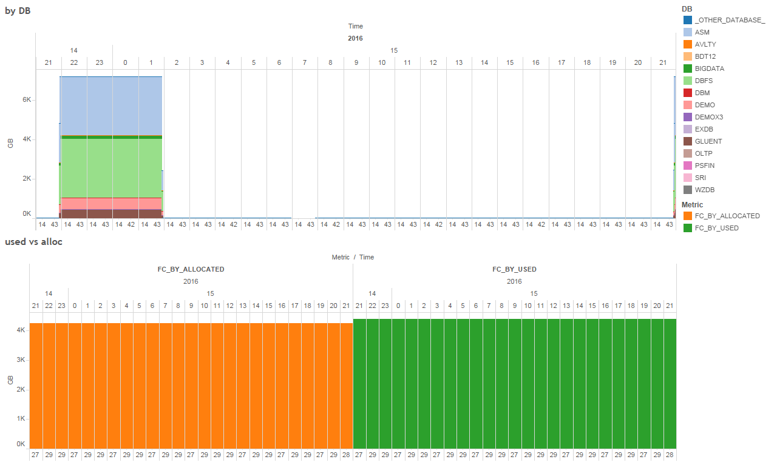

### Flash log outliers

Show occurrence of outliers on the flash log IOs

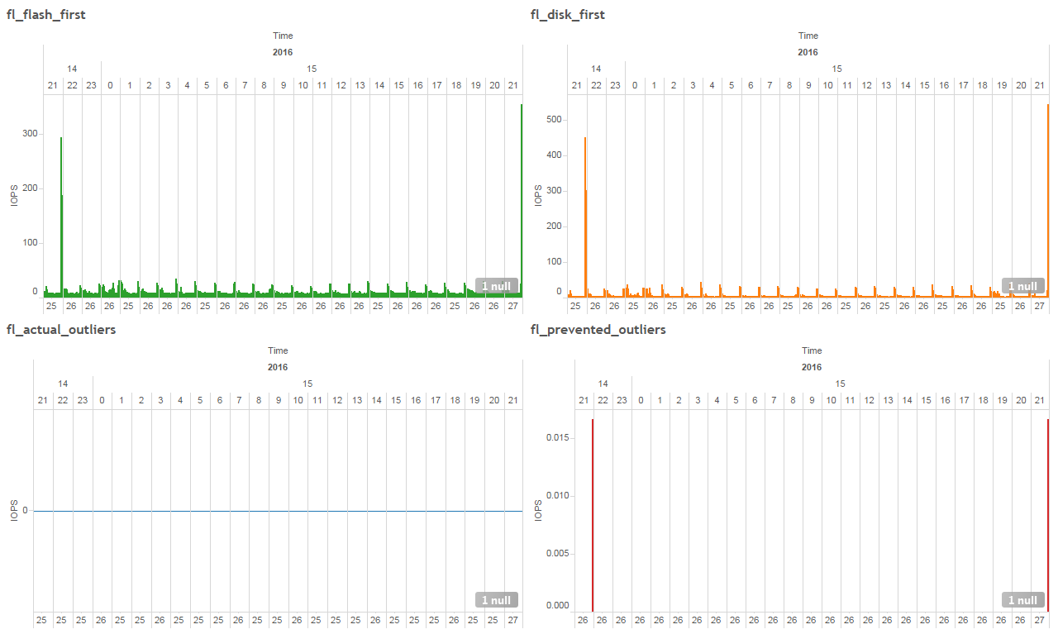

### Flash log efficiency and skip statistics

Flash log health metrics, useful for sizing the flash log

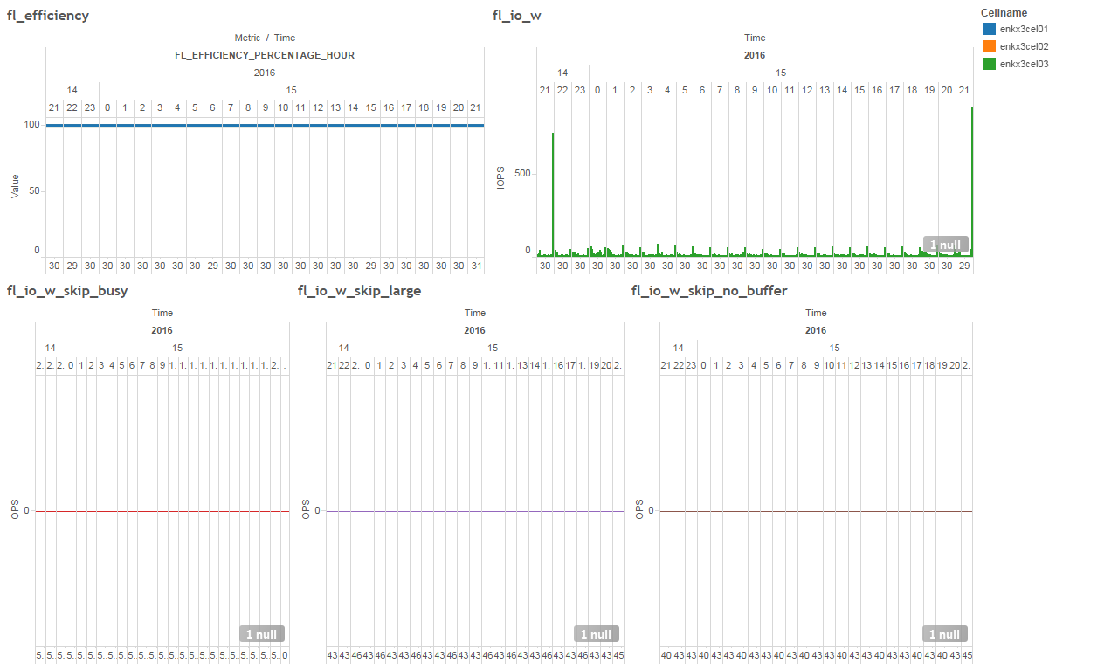

### DB level IOPS, MB/s, latency

Database level IO performance

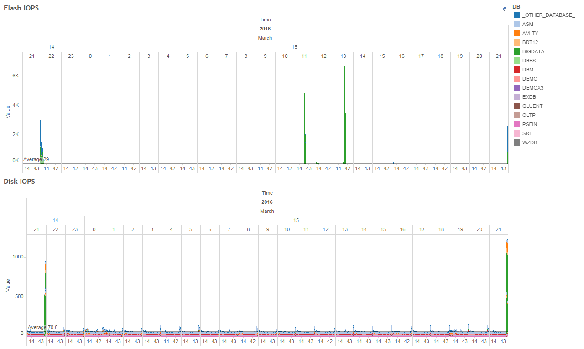

### CG level IOPS, MB/s, latency

Consumer group level IO performance

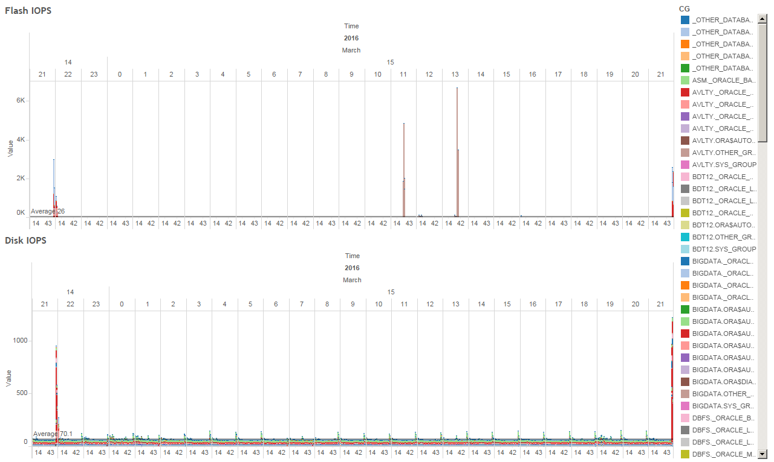

# HOWTO

## Login on the 1st storage cell

Make sure the cell_group file is created and passwordless SSH is working across storage cells

|  |
| --- |
| [root@enkx3cel01 ~]# cat cell_group  enkx3cel01  enkx3cel02  enkx3cel03  [root@enkx3cel01 ~]# pwd  /root |

## Create the gen_scl.sh script

|  |
| --- |
| [root@enkx3cel01 ~]# vi gen_scl.sh  echo "enter start time (format: 2016-03-14T01:00:00-06:00) ->"  read start_time  echo "enter end time (format: 2016-03-15T21:00:00-06:00) ->"  read end_time  # cell additional stats  cell_addtl_stats="CL_FSUT,CL_CPUT,CL_MEMUT,IORM_MODE,SIO_IO_RV_OF_SEC,SIO_IO_PA_TH_SEC"  # cell iops  cell_iops="CD_IO_RQ_R_LG_SEC,CD_IO_RQ_R_SM_SEC,CD_IO_RQ_W_LG_SEC,CD_IO_RQ_W_SM_SEC"  # cell mbs  cell_mbs="CD_IO_BY_R_LG_SEC,CD_IO_BY_R_SM_SEC,CD_IO_BY_W_LG_SEC,CD_IO_BY_W_SM_SEC"  # cell latency  cell_latency="CD_IO_TM_R_LG_RQ,CD_IO_TM_R_SM_RQ,CD_IO_TM_W_LG_RQ,CD_IO_TM_W_SM_RQ"  # flash space  # cell_flash_space="FC_BY_ALLOCATED,FC_BY_USED,DB_FC_BY_ALLOCATED"  cell_flash_space="FC_BY_ALLOCATED,FC_BY_USED"  # flash destage  cell_flash_destage="FC_IO_RQ_W_OVERWRITE_SEC,FC_IO_RQ_W_FIRST_SEC,FC_IO_RQ_R_MISS_SEC,FC_IO_RQ_W_POPULATE_SEC,FC_IO_RQ_DISK_WRITE_SEC"  # flashlog skip  cell_flashlog_skip="FL_EFFICIENCY_PERCENTAGE_HOUR,FL_IO_W,FL_IO_W_SKIP_BUSY,FL_IO_W_SKIP_LARGE,FL_IO_W_SKIP_NO_BUFFER"  # flashlog outliers  cell_flashlog_outliers="FL_FLASH_FIRST,FL_DISK_FIRST,FL_PREVENTED_OUTLIERS,FL_ACTUAL_OUTLIERS"  # db iops  cell_db_iops="DB_IO_RQ_LG_SEC,DB_IO_RQ_SM_SEC,DB_FD_IO_RQ_LG_SEC,DB_FD_IO_RQ_SM_SEC"  # db mbs  cell_db_mbs="DB_IO_BY_SEC,DB_FC_IO_BY_SEC,DB_FD_IO_BY_SEC,DB_FL_IO_BY_SEC"  # db latency  cell_db_latency="DB_FD_IO_WT_LG_RQ,DB_FD_IO_WT_SM_RQ,DB_IO_WT_LG_RQ,DB_IO_WT_SM_RQ"  # cg iops  cell_cg_iops="CG_IO_RQ_LG_SEC,CG_IO_RQ_SM_SEC,CG_FD_IO_RQ_LG_SEC,CG_FD_IO_RQ_SM_SEC"  # cg mbs  cell_cg_mbs="CG_IO_BY_SEC,CG_FC_IO_BY_SEC,CG_FD_IO_BY_SEC"  # cg latency  cell_cg_latency="CG_FD_IO_WT_LG_RQ,CG_FD_IO_WT_SM_RQ,CG_IO_WT_LG_RQ,CG_IO_WT_SM_RQ"  for i in ${!cell_*}; do  echo "set dateformat local" >> $i.scl  echo "LIST METRICHISTORY ${!i} where collectionTime > '$start_time' and collectionTime < '$end_time'" >> $i.scl  echo "/usr/local/bin/dcli -l root -g /root/cell_group -f ~/$i.scl" >> distribute_scl.sh  echo "/usr/local/bin/dcli --serial -l root -g /root/cell_group "cellcli -e start $i.scl" | bzip2 > $i.txt.bz2" >> run_scl.sh  done |

## Execute the gen_scl.sh script

This script will generate the following:

* .scl files
  + The LIST METRICHISTORY commands
* distribute_scl.sh
  + Distributes the .scl files across the storage cells
* run_scl.sh
  + Executes all the .scl files sequentially across the storage cells and generates a .bz2 file for each .scl

On prompt, start and end date filters will be asked. Input the proper date filters and time zone accordingly. **The time zone for PST is -8, CST is -6, and EST is -5.**

|  |
| --- |
| sh gen_scl.sh |

## Execute the distribute_scl.sh script

Distribute the .scl files across the storage cells

|  |
| --- |
| sh distribute_scl.sh |

## Execute the run_scl.sh script

Execute all the .scl files sequentially across the storage cells.

This is a low footprint data collection. The --serial allows running serially for each of the storage cells and the bzip2 is for compressing the data set on the fly which makes the space usage footprint on the filesystem very small.

|  |
| --- |
| sh run_scl.sh |

Below shows the load average on the storage cell during collection period

[root@enkx3cel01 ~]# top -c

top - 02:48:52 up 15 days, 1:50, 2 users, load average: 1.59, 1.75, 1.62

Tasks: 257 total, 2 running, 255 sleeping, 0 stopped, 0 zombie

Cpu(s): 3.4%us, 2.0%sy, 0.0%ni, 94.6%id, 0.0%wa, 0.0%hi, 0.0%si, 0.0%st

Mem: 65661560k total, 23323212k used, 42338348k free, 430256k buffers

Swap: 2097084k total, 0k used, 2097084k free, 3984632k cached

PID USER PR NI VIRT RES SHR S %CPU %MEM TIME+ COMMAND

18809 root 20 0 13552 6936 484 R 55.4 0.0 0:06.71 bzip2

18808 root 20 0 389m 40m 3396 S 46.8 0.1 0:17.36 python /usr/local/bin/dcli --serial -l root -g /root/cell_group cellcli -e

## Copy the .bz2 files

Stage the .bz2 files **to a filesystem w/ enough space which is at least 5GB**

## Process the files – create and run the process_files.sh

The following commands will do the following:

* Extract all the .bz2 files
* Massage the file for visualization
* Zip the final data set

|  |
| --- |
| vi process_files.sh  bunzip2 *bz2  cell_addtl_stats.txt  sed -n -i '2,$ p' cell_addtl_stats.txt  sed -i 's/%/ /g' cell_addtl_stats.txt  sed -i 's/MB\/sec/ /g' cell_addtl_stats.txt  sed -i 's/: /\t/g' cell_addtl_stats.txt  sed -i '1 i\cellname\tmetric\tdisk\tvalue\ttime' cell_addtl_stats.txt  zip cell_addtl_stats.zip cell_addtl_stats.txt  cell_cg_iops.txt  sed -n -i '2,$ p' cell_cg_iops.txt  sed -i 's/IO\/sec/ /g' cell_cg_iops.txt  sed -i 's/: /\t/g' cell_cg_iops.txt  sed -i '1 i\cellname\tmetric\tdisk\tvalue\ttime' cell_cg_iops.txt  zip cell_cg_iops.zip cell_cg_iops.txt  cell_cg_latency.txt  sed -n -i '2,$ p' cell_cg_latency.txt  sed -i 's/ms\/request/ /g' cell_cg_latency.txt  sed -i 's/: /\t/g' cell_cg_latency.txt  sed -i '1 i\cellname\tmetric\tdisk\tvalue\ttime' cell_cg_latency.txt  zip cell_cg_latency.zip cell_cg_latency.txt  cell_cg_mbs.txt  sed -n -i '2,$ p' cell_cg_mbs.txt  sed -i 's/MB\/sec/ /g' cell_cg_mbs.txt  sed -i 's/: /\t/g' cell_cg_mbs.txt  sed -i '1 i\cellname\tmetric\tdisk\tvalue\ttime' cell_cg_mbs.txt  zip cell_cg_mbs.zip cell_cg_mbs.txt  cell_db_iops.txt  sed -n -i '2,$ p' cell_db_iops.txt  sed -i 's/IO\/sec/ /g' cell_db_iops.txt  sed -i 's/: /\t/g' cell_db_iops.txt  sed -i '1 i\cellname\tmetric\tdisk\tvalue\ttime' cell_db_iops.txt  zip cell_db_iops.zip cell_db_iops.txt  cell_db_latency.txt  sed -n -i '2,$ p' cell_db_latency.txt  sed -i 's/ms\/request/ /g' cell_db_latency.txt  sed -i 's/: /\t/g' cell_db_latency.txt  sed -i '1 i\cellname\tmetric\tdisk\tvalue\ttime' cell_db_latency.txt  zip cell_db_latency.zip cell_db_latency.txt  cell_db_mbs.txt  sed -n -i '2,$ p' cell_db_mbs.txt  sed -i 's/MB\/sec/ /g' cell_db_mbs.txt  sed -i 's/: /\t/g' cell_db_mbs.txt  sed -i '1 i\cellname\tmetric\tdisk\tvalue\ttime' cell_db_mbs.txt  zip cell_db_mbs.zip cell_db_mbs.txt  cell_flash_destage.txt  sed -n -i '2,$ p' cell_flash_destage.txt  sed -i 's/IO\/sec/ /g' cell_flash_destage.txt  sed -i 's/: /\t/g' cell_flash_destage.txt  sed -i '1 i\cellname\tmetric\tdisk\tvalue\ttime' cell_flash_destage.txt  zip cell_flash_destage.zip cell_flash_destage.txt  cell_flash_space.txt  sed -n -i '2,$ p' cell_flash_space.txt  sed -i 's/MB/ /g' cell_flash_space.txt  sed -i 's/: /\t/g' cell_flash_space.txt  sed -i '1 i\cellname\tmetric\tdisk\tvalue\ttime' cell_flash_space.txt  zip cell_flash_space.zip cell_flash_space.txt  cell_flashlog_outliers.txt  sed -n -i '2,$ p' cell_flashlog_outliers.txt  sed -i 's/IO requests/ /g' cell_flashlog_outliers.txt  sed -i 's/: /\t/g' cell_flashlog_outliers.txt  sed -i '1 i\cellname\tmetric\tdisk\tvalue\ttime' cell_flashlog_outliers.txt  zip cell_flashlog_outliers.zip cell_flashlog_outliers.txt  cell_flashlog_skip.txt  sed -n -i '2,$ p' cell_flashlog_skip.txt  sed -i 's/%/ /g' cell_flashlog_skip.txt  sed -i 's/IO requests/ /g' cell_flashlog_skip.txt  sed -i 's/: /\t/g' cell_flashlog_skip.txt  sed -i '1 i\cellname\tmetric\tdisk\tvalue\ttime' cell_flashlog_skip.txt  zip cell_flashlog_skip.zip cell_flashlog_skip.txt  cell_iops.txt  sed -n -i '2,$ p' cell_iops.txt  sed -i 's/IO\/sec/ /g' cell_iops.txt  sed -i 's/: /\t/g' cell_iops.txt  sed -i '1 i\cellname\tmetric\tdisk\tvalue\ttime' cell_iops.txt  zip cell_iops.zip cell_iops.txt  cell_latency.txt  sed -n -i '2,$ p' cell_latency.txt  sed -i 's/us\/request/ /g' cell_latency.txt  sed -i 's/: /\t/g' cell_latency.txt  sed -i '1 i\cellname\tmetric\tdisk\tvalue\ttime' cell_latency.txt  zip cell_latency.zip cell_latency.txt  cell_mbs.txt  sed -n -i '2,$ p' cell_mbs.txt  sed -i 's/MB\/sec/ /g' cell_mbs.txt  sed -i 's/: /\t/g' cell_mbs.txt  sed -i '1 i\cellname\tmetric\tdisk\tvalue\ttime' cell_mbs.txt  zip cell_mbs.zip cell_mbs.txt |

Execute the process_files.sh

|  |
| --- |
| sh process_files.sh |

## Email the 14 zip files